

SUBJECT : Artificial Intelligence
Prof : Mam Attiqa

Project : Adaptive learning system

Group Members
- Aira (223587)
- Unaiza (233787)
- Fatima Khalid (233526)
- Somal (233530)

1. Introduction
This project presents an Artificial Intelligence–based student performance analytics system designed to analyze learning behavior and recommend personalized learning paths. The system uses interactive dashboards and AI-driven logic to assist both students and teachers in academic decision-making.

2. Objectives
- Analyze student performance using AI techniques
- Visualize academic metrics through dashboards
- Recommend learning paths using AI logic
- Provide teacher-level performance insights
- Demonstrate real-world AI application

3. Module Descriptions

3.1 Module 1: Data Collection & Preprocessing
This module is responsible for collecting student-related data such as quiz scores, study time, and engagement levels. The collected data is preprocessed using the following steps:
- Handling missing or inconsistent values
- Normalizing numerical data
- Preparing clean and structured input for the AI model

This module ensures data quality, which is essential for accurate AI analysis.

3.2 Module 2: AI Model Development
In this module, an Artificial Intelligence model is developed to analyze student performance. The model evaluates input features and identifies learning patterns. Based on performance thresholds and analytical rules, the AI model categorizes students into learning levels such as:
- Beginner
- Intermediate
- Advanced

This module forms the core intelligence of the system.

3.3 Module 3: Adaptive Recommendation System
This module uses the output of the AI model to generate adaptive and personalized learning recommendations. Depending on the student’s performance level, the system suggests:
- Appropriate learning paths
- Study intensity adjustments
- Skill improvement focus areas

The recommendation system dynamically adapts as new student data is provided.

3.4 Module 4: User Interface & System Integration
This module focuses on the design and integration of the complete system. It includes:
- Student Portal for performance input and analysis
- Teacher Insights dashboard for class-level analytics
- Interactive visualizations such as nested charts and predictor maps

4. Key Features
4.1 Performance Input Controls
- Quiz Score (%) slider
- Study Time (Minutes) slider
- Engagement Level indicator
These parameters act as input features for AI-based analysis.
4.2 AI Recommendation Engine
Based on the input metrics, the system recommends learning paths such as:
- Beginner
- Intermediate
- Advanced
This recommendation is generated by analyzing performance thresholds and engagement patterns.
4.3 Interactive Data Visualization
The application includes:
- Nested Circle Charts for individual performance metrics
- Scatter Plot Predictor Map for class-level performance analysis

5. AI Implementation
The AI logic uses performance thresholds and engagement analysis to categorize students into learning paths such as Beginner, Intermediate, and Advanced.

6. Data Visualization
- Nested Circle Charts for individual performance metrics
- Scatter Plot Predictor Map for class-level analysis

7. Tools and Technologies
- Python
- Gradio Framework
- NumPy, Pandas
- Matplotlib / Plotly

8. Results
The system successfully provides real-time analytics, AI-based recommendations, and visual insights that support improved learning outcomes.

9. Conclusion
This project demonstrates the effective application of Artificial Intelligence in education by integrating analytics, visualization, and intelligent recommendations.

10. Future Enhancements
  - Machine learning model integration
  - Cloud deployment
  - Database integration
  - Authentication and role-based access
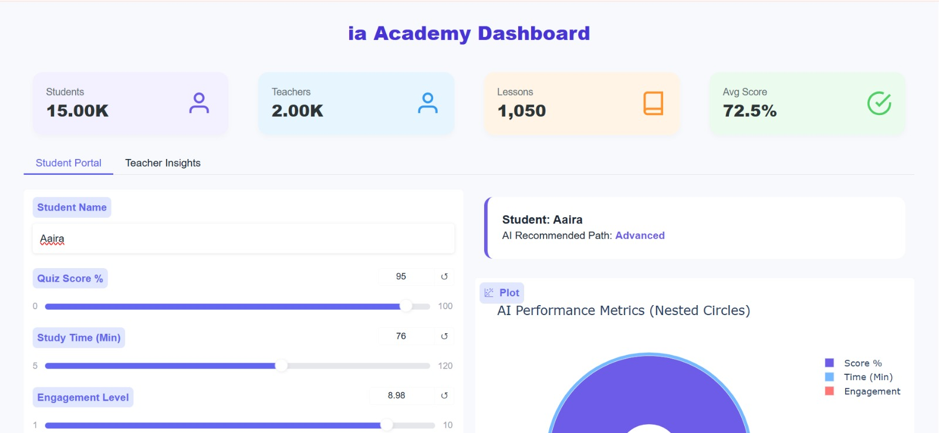
OUTPUTS

Description 1
This screenshot represents the main dashboard of the AI-based system, displaying overall statistics such as total students, teachers, lessons, and average performance score.
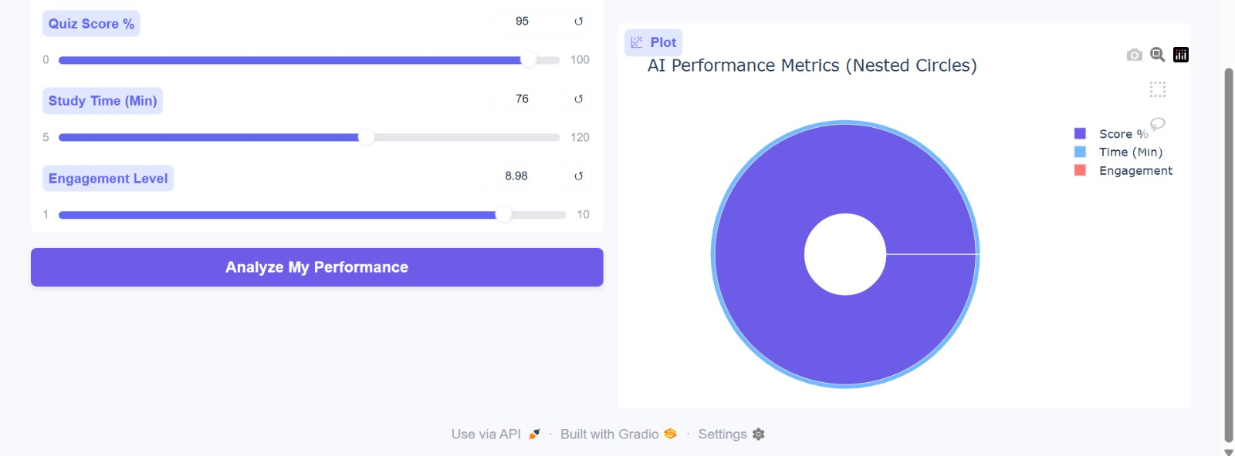

Description:
This screenshot illustrates the student portal where academic inputs are analyzed and an AI-based adaptive learning path is recommended.

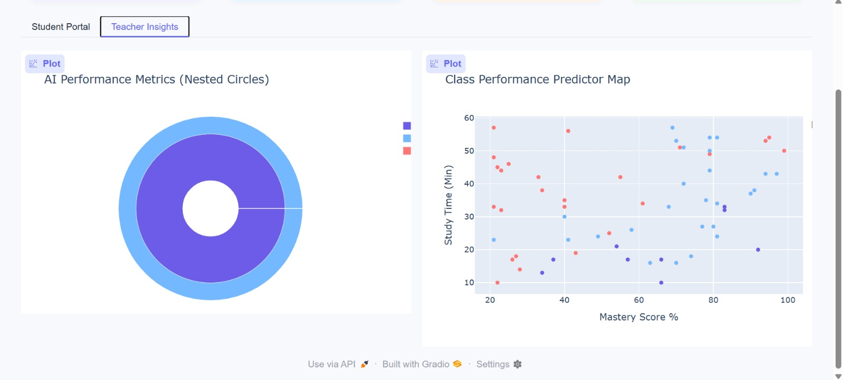

Description:
This screenshot shows the teacher insights dashboard, including AI performance metrics and a class performance predictor map used for academic analysis.

